Table 1: Descriptive Statistics of Key Variables across Policy Management Units of the Thames Estuary
 | Target Variable |  | Structural Controls
 | Price (£) |  | Total Floor Area (m²) |  | Property Types – N (%)
 | Mean (SD) | (Min: Max) | Mean (SD) | (Min, Max) | Bungalow | Flat | House | Maisonette
Barking & Dagenham | 281,503.32 (148,046.9) | (100: 9,345,000) | 78.59 (24.95) | (7.80: 297) | 46 (0.6%) | 1,467 (18%) | 6,630 (80%) | 165 (2.0%)
Canvey Island | 254,154.92 (93,459.44) | (500: 1,300,000) | 84.55 (38.68) | (13: 875) | 3,582 (47%) | 86 (1.1%) | 3,927 (52%) | 27 (0.4%)
Dartford & Erith | 272,889.93 (332,545.9) | (6,400: 21,812,419) | 77.00 (25.70) | (18: 395) | 2 (<0.1%) | 1,952 (36%) | 3,344 (62%) | 125 (2.3%)
East Tilbury & Mucking Mashes | 275,865.39 (90,648.97) | (55,000: 750,000) | 87.03 (32.08) | (36: 442) | 0 (0%) | 9 (2.3%) | 384 (98%) | 0 (0%)
Greenwich | 546,806.77 (280,278.1) | (6,500: 3,500,000) | 89.78 (33.99) | (14.00: 304.00) | 1 (<0.1%) | 673 (25%) | 1,814 (67%) | 226 (8.3%)
Isle of Dogs & Lea Valley | 455,572.21(452,208.17) | (100: 17,220,000) | 77.54 (34.95) | (10.00: 811.43) | 3 (<0.1%) | 1,919 (53%) | 1,171 (32%) | 519 (14%)
Isle of Grain | 420,000.00 () | (420,000: 420,000) | 168 () | (168: 168) | 0 (0%) | 0 (0%) | 1 (100%) | 0 (0%)
Leigh Old Town and Southend-on-Sea | 424,062.29 (261,574.4) | (4,500: 2,425,000) | 119.80 (68.40) | (5.24: 2,148.00) | 580 (19%) | 600 (19%) | 1,856 (60%) | 50 (1.6%)
London City | 585,690.23 (337,081.9) | (29,465: 3,500,000) | 74.44 (36.40) | (23.00, 375.13) | 0 (0%) | 318 (50%) | 237 (37%) | 80 (13%)
North Kent | 247,879.84 (92,278.95) | (10,000: 590,000) | 82.20 (22.29) | (25.10, 336.00) | 59 (6.0%) | 46 (4.6%) | 870 (88%) | 16 (1.6%)
Purfleet, Grays & Tilbury | 231,804.16 (723,185.7) | (15,000:40,779,191) | 72.09 (23.92) | (18.47: 520.00) | 60 (0.9%) | 2,027 (32%) | 4,213 (66%) | 121 (1.9%)
Rainham Marshes | 314,959.77 (107,789.2) | (26,730: 670,000) | 86.57 (23.57) | (33.48: 217.00) | 434 (15%) | 238 (8.1%) | 2,155 (73%) | 116 (3.9%)
Royal Docks | 322,365.66 (202,762.9) | (100: 10,080,000) | 79.24 (28.94) | (8.04: 1,570.00) | 41 (0.3%) | 3,382 (25%) | 9,554 (70%) | 649 (4.8%)
Shell Haven & Fobbing Marshes | 237,751.64 (88,261.16) | (5,000: 630,000) | 76.35 (26.40) | (36.00: 216.00) | 4 (1.4%) | 51 (18%) | 220 (77%) | 12 (4.2%)
Swanscombe & Northfleet | 359,346.91 (114,576.6) | (64,995: 750,000) | 99.86 (29.32) | (37.10: 212.00) | 0 (0%) | 4 (5.8%) | 63 (91% | 2 (2.9%)
Thamesmead | 263,650.16 (192,867.7) | (3,250: 11,915,135) | 74.76 (24.23) | (4.80: 503.00) | 100 (1.6%) | 1,450 (23%) | 4,648 (73%) | 160 (2.5%)
Wandsworth to Deptford | 523,421.35 (649,990.5) | (500: 57,285,700) | 80.83 (39.54) | (4.70: 1,409.00) | 10 (<0.1%) | 4,438 (42%) | 4,929 (47%) | 1,173 (11%)
Overall (N = 73,039) | 342,552.65 (397,875.3) | (100: 57,285,700) | 81.13 (34.55) | (4.70: 2,148.00) | 4,922 (6.7%) | 18,660 (26%) | 46,016 (63%) | 3,441 (4.7%)

Table 1: Descriptive Statistics of Key Variables across Policy Management Units of the Thames Estuary (Cont’d)
 | Structural Controls |  |  |  |  |  |  | Neighbourhood Controls
 | Energy Ratings (A - G) – N(%) |  |  |  |  |  |  | Net Annual Income
 | A | B | C | D | E | F | G | Mean (SD) | (Min: Max)
Barking & Dagenham | 9 (0.1%) | 544 (6.5%) | 1,738 (21%) | 4,264 (51%) | 1,428 (17%) | 213 (2.6%) | 112 (1.3%) | 31,946.13 (2,148.35) | (25,985: 35,072)
Canvey Island | 5 (<0.1%) | 166 (2.2%) | 1,218 (16%) | 4,169 (55%) | 1,685 (22%) | 305 (4.0%) | 74 (1.0%) | 32,986.66 (1,093.06) | (31,105: 34,650)
Dartford & Erith | 61 (1.1%) | 3,100 (57%) | 912 (17%) | 1,020 (19%) | 263 (4.8%) | 54 (1.0%) | 13 (0.2%) | 34,554.92 (1,478.35) | (31,592: 42,170)
East Tilbury & Mucking Mashes | 0 (0%) | 32 (8.1%) | 76 (19%) | 209 (53%) | 69 (18%) | 4 (1.0%) | 3 (0.8%) | 36,118.90 (150.19) | (36,088: 36,847)
Greenwich | 9 (0.3%) | 389 (14%) | 636 (23%) | 1,128 (42%) | 454 (17%) | 61 (2.2%) | 37 (1.4%) | 47,401.68 (4,299.22) | (32,610: 50,012)
Isle of Dogs & Lea Valley | 1 (<0.1%) | 271 (7.5%) | 1,836 (51%) | 1,225 (34%) | 233 (6.5%) | 40 (1.1%) | 6 (0.2%) | 36,363.32 (5,050.86) | (26,517: 48,749)
Isle of Grain | 0 (0%) | 0 (0%) | 0 (0%) | 0 (0%) | 1 (100%) | 0 (0%) | 0 (0%) | 34,633.00 (NA) | (34,633: 34,633)
Leigh Old Town and Southend-on-Sea | 0 (0%) | 72 (2.3%) | 377 (12%) | 1,229 (40%) | 1,028 (33%) | 336 (11%) | 44 (1.4%) | 38,613.31 (6,840.70) | (25,521: 43,932)
London City | 0 (0%) | 14 (2.2%) | 324 (51%) | 235 (37%) | 35 (5.5%) | 19 (3.0%) | 8 (1.3%) | 44,937.11 (7,251.50) | (33,051: 53,735)
North Kent | 0 (0%) | 151 (15%) | 158 (16%) | 488 (49%) | 164 (17%) | 20 (2.0%) | 10 (1.0%) | 33,059.00 (0.00) | (33,059: 33,059)
Purfleet, Grays & Tilbury | 33 (0.5%) | 1,211 (19%) | 1,771 (28%) | 2,554 (40%) | 698 (11%) | 107 (1.7%) | 47 (0.7%) | 30,560.50 (2,176.55) | (27,850: 35,752)
Rainham Marshes | 0 (0%) | 384 (13%) | 508 (17%) | 1,340 (46%) | 604 (21%) | 83 (2.8%) | 24 (0.8%) | 38,792.09 (1,214.62) | (38,297: 43,106)
Royal Docks | 3 (<0.1%) | 753 (5.5%) | 3,520 (26%) | 6,553 (48%) | 2,205 (16%) | 376 (2.8%) | 216 (1.6%) | 30,426.11 (4,919.76) | (22,035: 46,930.00)
Shell Haven & Fobbing Marshes | 1 (0.3%) | 1 (0.3%) | 74 (26%) | 111 (39%) | 83 (29%) | 14 (4.9%) | 3 (1.0%) | 35,735.44 (1,169.12) | (31,872: 36,088)
Swanscombe & Northfleet | 0 (0%) | 50 (72%) | 2 (2.9%) | 6 (8.7%) | 8 (12%) | 2 (2.9%) | 1 (1.4%) | 30,890.20 (2,480.23) | (26,896: 32,408.00)
Thamesmead | 1 (<0.1%) | 203 (3.2%) | 2,457 (39%) | 2,635 (41%) | 859 (14%) | 165 (2.6%) | 38 (0.6%) | 34,340.62 (2,122.20) | (30,572: 52,998.00)
Wandsworth to Deptford | 14 (0.1%) | 686 (6.5%) | 4,071 (39%) | 4,130 (39%) | 1,287 (12%) | 257 (2.4%) | 105 (1.0%) | 40,797.65 (5,493.56) | (33,608: 63,550.00)
Overall (N = 73,039) | 137 (0.2%) | 8,027 (11%) | 19,678 (27%) | 31,296 (43%) | 11,104 (15%) | 2,056 (2.8%) | 741 (1.0%) | 34,844.72 (5,900.96) | (22,035: 63,550.00)

Table 1: Descriptive Statistics of Key Variables across Policy Management Units of the Thames Estuary (Cont’d)
 | Neighbourhood Controls |  | Climate and Environment Variables
 | Total Time to Work (Min) |  | Flood Risk Levels – N (%) |  |  | Elevation (m) |  | Distance to River (m)
 | Mean (SD) | (Min: Max) | No Risk | Mid Risk | High Risk | Mean (SD) | (Min: Max) | Mean (SD) | (Min: Max)
Barking & Dagenham | 5.36 (2.82) | (2.30, 12.22) | 5,919 (71%) | 444 (5.3%) | 1,945 (23%) | 5.14 (1.65) | (-2.30: 11.90) | 750.18 (400.96) | (31.27: 2,076.7)
Canvey Island | 6.73 (3.22) | (2.88, 16.27) | 0 (0%) | 0 (0%) | 7,622 (100%) | 1.87 (0.37) | (-0.40: 3.80) | 551.44(396.45) | (10.31: 1,487.5)
Dartford & Erith | 10.76 (3.65) | (2.98, 17.56) | 2,085 (38%) | 1,000 (18%) | 2,338 (43%) | 6.13 (1.71) | (-2.20, 12.00) | 425.61 (289.56) | (27.49: 1,145.6)
East Tilbury & Mucking Mashes | 6.05 (3.92) | (3.00, 12.77) | 293 (75%) | 100 (25%) | 0 (0%) | 6.77 (1.61) | (-2.10, 9.90) | 230.10 (146.48) | (34.80: 914.40)
Greenwich | 4.84 (2.15) | (1.66, 8.24) | 777 (29%) | 237 (8.7%) | 1,700 (63%) | 4.72 (2.03) | (-2.30, 17.70) | 602.12 (336.60) | (31.97: 1,281.9)
Isle of Dogs & Lea Valley | 3.49 (1.74) | (1.07, 9.35) | 847 (23%) | 387 (11%) | 2,378 (66%) | 4.10 (1.45) | (-2.30, 9.60) | 436.95 (234.03) | (18.26, 1,042.34)
Isle of Grain | 9.71 (NA) | (9.71, 9.71) | 0 (0%) | 0 (0%) | 1 (100%) | 5.50 (NA) | (5.50, 5.50) | 0.07 (NA) | (0.07 0.07)
Leigh Old Town and Southend-on-Sea | 4.93 (1.78) | (2.28, 9.49) | 1,792 (58%) | 892 (29%) | 402 (13%) | 5.79 (2.56) | (0.90, 13.00) | 660.91 (333.25) | (13.98, 1,488.1)
London City | 4.80 (1.81) | (3.10, 16.36) | 69 (11%) | 20 (3.1%) | 546 (86%) | 4.26 (1.05) | (2.50, 9.70) | 405.65 (116.00) | (174.29, 614.37)
North Kent | 8.56 (3.70) | (4.18, 12.74) | 438 (44%) | 28 (2.8%) | 525 (53%) | 5.83 (2.17) | (2.80, 11.60) | 798.98 (276.88) | (166 1,264.65)
Purfleet, Grays & Tilbury | 5.95 (2.76) | (2.05, 10.68) | 2,347 (37%) | 1,260 (20%) | 2,814 (44%) | 5.22 (4.22) | (0.00, 16.50) | 525.29 (275.20) | (29.32, 1,211.8)
Rainham Marshes | 7.57 (3.39) | (2.90, 12.44) | 1,875 (64%) | 297 (10%) | 771 (26%) | 5.08 (1.80) | (1.50, 8.80) | 481.38 (249.69) | (19.70, 1,118.2)
Royal Docks | 3.77 (1.55) | (1.28, 8.07) | 5,164 (38%) | 1,583 (12%) | 6,879 (50%) | 3.62 (1.97) | (-2.30, 9.70) | 1,251.34 (601.1) | (27.49, 2,581.1)
Shell Haven & Fobbing Marshes | 9.25 (2.73) | (3.92, 13.48) | 228 (79%) | 24 (8.4%) | 35 (12%) | 7.42 (2.28) | (-2.10, 11.30) | 113.11 (127.39) | (20.23, 515.43)
Swanscombe & Northfleet | 10.06 (0.02) | (10.05, 10.11) | 65 (94%) | 0 (0%) | 4 (5.8%) | 8.17 (1.38) | (4.30, 9.30) | 635.34 (90.02) | (415.62, 718.92)
Thamesmead | 5.74 (3.11) | (1.76, 12.33) | 1,756 (28%) | 236 (3.7%) | 4,366 (69%) | 3.17 (2.67) | (-2.30, 12.30) | 471.56 (272.36) | (14.75, 1,278.6)
Wandsworth to Deptford | 4.59 (2.91) | (1.07, 18.15) | 1,620 (15%) | 793 (7.5%) | 8,137 (77%) | 3.51 (1.41) | (-2.30, 13.50) | 1,334.57 (825.6) | (27.67, 3,288.6)
Overall (N = 73,039) | 5.50 (3.18) | (1.07, 18.15) | 25,275 (35%) | 7,301 (10.0%) | 40,463 (55%) | 4.17 (2.46) | (-2.30, 17.70) | 795.87 (604.67) | (0.07, 3,288.60)

The descriptive statistics reveal a highly heterogeneous property market across the Thames Estuary. Mean property prices range from £231,804 in Purfleet, Grays & Tilbury to £585,690 in London City, reflecting a significant wealth gradient between the eastern estuary and the western urban core.
Exposure is unevenly distributed; while Canvey Island is 100% situated within a High-Risk zone (FZ3), units like East Tilbury & Mucking Marshes have 0% High-Risk exposure. The housing stock varies significantly by unit, with Canvey Island dominated by bungalows (47%) and Isle of Dogs dominated by flats (53%), necessitating the use of structural controls to isolate the specific impact of flood risk.

Table 2: Pearson Correlation Matrix and Variance Inflation Factor
 | Price | TFA | Elevation | Distance | Income | Travel | VIF
Price | 1 |  |  |  |  |  | --
TFA | 0.27 | 1 |  |  |  |  | 1.43
Elevation | 0.01 | 0.06 | 1 |  |  |  | 2.63
Distance | 0.06 | 0.00 | 0.00 | 1.00 |  |  | 1.82
Income | 0.22 | 0.13 | 0.03 | -0.11 | 1.00 |  | 2.71
Travel | -0.04 | -0.01 | 0.06 | -0.28 | 0.04 | 1.00 | 1.41
Flood risk |  |  |  |  |  |  | 3.03
Property |  |  |  |  |  |  | 2.27

Table 3 reports the results of global spatial diagnostic tests conducted on the residuals of the baseline hedonic price model. The Moran’s I statistic for the regression residuals is 0.1397, with a z-score of 75.65 and a p-value below 0.001, indicating extremely strong positive spatial autocorrelation, proving that housing prices in one location are heavily influenced by their neighbours. In other words, the OLS specification fails to capture spatially structured factors influencing property values, such as neighbourhood reputation, local environmental characteristics, etc. Also, the presence of spatial autocorrelation violates the classical OLS assumption of independently distributed errors and may lead to biased inference and inefficient coefficient estimates. Consequently, the baseline hedonic model provides an incomplete representation of the spatial processes underlying housing price formation.
To further examine the nature of the spatial dependence, Rao’s Score (Lagrange Multiplier) tests were conducted for both spatial lag and spatial error processes. The results show that both forms of spatial dependence are highly significant (p-value < 0.001), providing strong evidence that spatial processes influence housing prices in the study area, with spatial lag dependence implying that housing prices in one location are influenced by prices in neighbouring areas, while spatial error dependence reflects that unobserved spatially correlated factors, such as environmental amenities or local flood protection characteristics, affect housing prices
Furthermore, while these global spatial models address spatial dependence, they continue to impose constant marginal effects across space. This limitation motivates the subsequent use of Geographically Weighted Regression (GWR) to capture spatial heterogeneity in the pricing of flood risk and adaptation infrastructure.

Table 3: Spatial Autocorrelation Diagnostics
Moran’s I Test for Residual Spatial autocorrelation
Statistic | Value
Moran’s I | 0.1397
Expected I | -0.00038
Variance | 0.00000343
z-value | 75.653
p-value | <0.001
Rao’s Score (Lagrange Multiplier) Tests
Test | Statistic | p-value
LM Error | 5674.51 | <0.001
LM Lag | 5929.91 | <0.001
Robust LM Error | 583.82 | <0.001
Robust LM Lag | 839.23 | <0.001
Notes: Moran’s I tests for global spatial autocorrelation in the residuals of the baseline hedonic regression. Rao’s Score (Lagrange Multiplier) diagnostics examine the presence of spatial lag and spatial error dependence. Robust tests control for the presence of the alternative spatial process. All statistics are calculated using the spatial weights matrix $W$.
Table 4 reveals that across all specifications, structural property characteristics remain highly significant. Total floor area exhibits a strong positive association with transaction prices, confirming that larger properties command higher market values. Property type also plays a significant role, with flats generally selling at a discount relative to hou
ses. These results are consistent with the established hedonic housing literature and validate the structural specification of the model. Income levels exhibit a positive and statistically significant effect on property prices across all models, while travel time to employment centres is negatively associated with prices, indicating that accessibility remains a key determinant of urban housing demand.
The coefficients for flood risk indicators remain statistically significant across the OLS, SEM, and SDM models. Properties located within both medium and high flood risk zones exhibit measurable price effects relative to properties outside designated flood zones. Elevation exhibits a positive and statistically significant effect across all models, indicating that properties located at higher elevations command price premiums, likely reflecting reduced exposure to flood hazards. Similarly, greater distance from river channels is associated with higher property values, suggesting that the housing market internalises aspects of physical flood risk geography.
The Spatial Error Model reports a highly significant spatial error coefficient (λ = 0.1277), indicating that unobserved spatially correlated factors influence housing prices. The Spatial Lag Model also detects significant spatial interaction in prices, suggesting that housing prices in one location are partially influenced by prices in neighbouring areas

Table 4: Global Hedonic and Spatial Econometric Model Estimates
Variables | OLS | SEM | SDM
 | 10.740*** (0.0137) | 10.840*** (0.0316) | 10.894*** (0.0134)
Total Floor Area | 0.00547*** (0.000054) | 0.00409*** (0.000059) | 0.00548*** (0.000054)
Property Type:
Flat | -0.0514*** (0.00703) | -0.2309*** (0.00915) | -0.0513*** (0.00464)
House | 0.1537*** (0.00654) | 0.0858*** (0.00811) | 0.1551*** (0.00406)
Maisonette | 0.0103 (0.00991) | -0.1773*** (0.0115) | 0.0116
Income After Housing | 3.37e-05*** (3.03e-07) | 3.58e-05*** (3.03e-07) | 3.43e-05*** (3.03e-07)
Travel Time to Employment | -0.0143*** (0.000545) | -0.0124*** (0.00136) | -0.0145*** (0.000535)
Flood Risk
Medium | 0.0529*** (0.00654) | 0.0691*** (0.0146) | 0.0523*** (0.00654)
High | 0.1001*** (0.00547) | 0.1106*** (0.0129) | 0.1004*** (0.00527)
Elevation | 0.0137*** (0.00102) | 0.0163*** (0.00248) | 0.0137*** (0.000971)
Distance to River | 0.000135*** (2.94e-06) | 0.000143*** (7.27e-06) | 0.000136*** (2.96e-06)
Spatial Parameters & Model Diagnostics
Spatial Coeff |  | -0.00148*** (Rho, ρ) | 0.1277*** (Lambda, λ)
Log-Likelihood | - | -1999.95 | -35.586.96
AIC | 71,850 | 4,025.9 | 71,200
R² | 0.382 | - | -
Observations | 64,947 | 64,947 | 64,947
Note: Dependent variable is the logarithm of transaction price. Standard errors are reported in parentheses. The Spatial Error Model (SEM) accounts for spatial correlation in the regression error term, while the Spatial Durbin/Lag Model incorporates spatial dependence in the dependent variable through the spatial autoregressive parameter $ρ$. Spatial weights are constructed using a symmetric binary matrix based on the k = 8 nearest neighbours to maintain model stability across 64,947 observations. Due to the Sparse Matrix (Matrix) estimation method, the SEM Log-Likelihood and AIC operate on a different numerical scale than the OLS; model selection is therefore guided by the significance of the spatial parameters and the Likelihood Ratio (LR) test. Significance levels: *** p < 0.01, ** p < 0.05, * p < 0.10.

Figure 1 maps the transition of the flood risk coefficient $\left(β\right)$ from the western urban core to the eastern estuary. The map reveals a clear red-to-green transition; the Red clusters (0.08 to 0.23) represent areas of market failure where flood risk is associated with a price premium. The Green clusters (-0.47 to -0.06) represent areas where the market has internalized risk, providing a direct visual refutation of the Global SEM's fixed 10.6% premium estimate
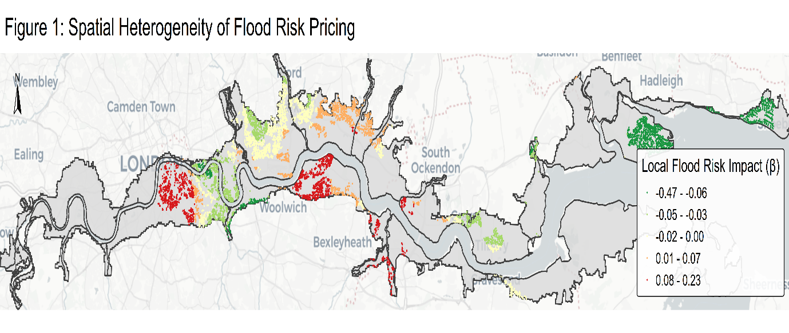
Figure 1: Spatial Heterogeneity of Local Flood Risk Coefficients (β) across the Thames Estuary

Figure 2 illustrates the spatial variation in the model's ability to explain property price variance.
- High-Performance Zones: The model achieves its highest explanatory power $\left(R^{2}>0.60\right)$ in Leigh-on-Sea and Wandsworth, suggesting that the selected structural and environmental variables are primary drivers of value in these settled residential markets.
- Unobserved Heterogeneity: Lower $R^{2}$ values (0.18 to 0.31) in the Royal Docks suggest that property values there may be influenced by unobserved factors not captured in the model, such as proximity to specific industrial regeneration projects or unique transport nodes.

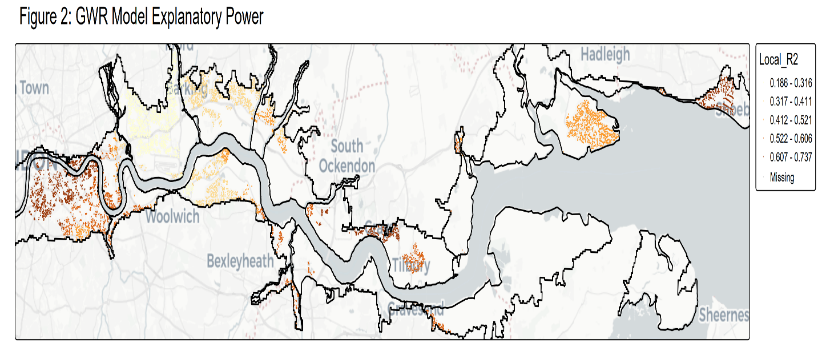
Figure 2: Spatial Distribution of GWR Model Explanatory Power (Local R²)

The LISA cluster map identifies statistically significant hotspots of mispricing that warrant policy intervention. The High-High (Blue) clusters represent valuation bubbles—areas where both property values and flood risk impacts are high, indicating a dangerous decoupling of market price from environmental reality. The Low-Low (Red) clusters in the east identify climate-rational zones where property values are consistently lower in high-risk areas, representing a market that has successfully adapted its pricing to reflect physical risk.
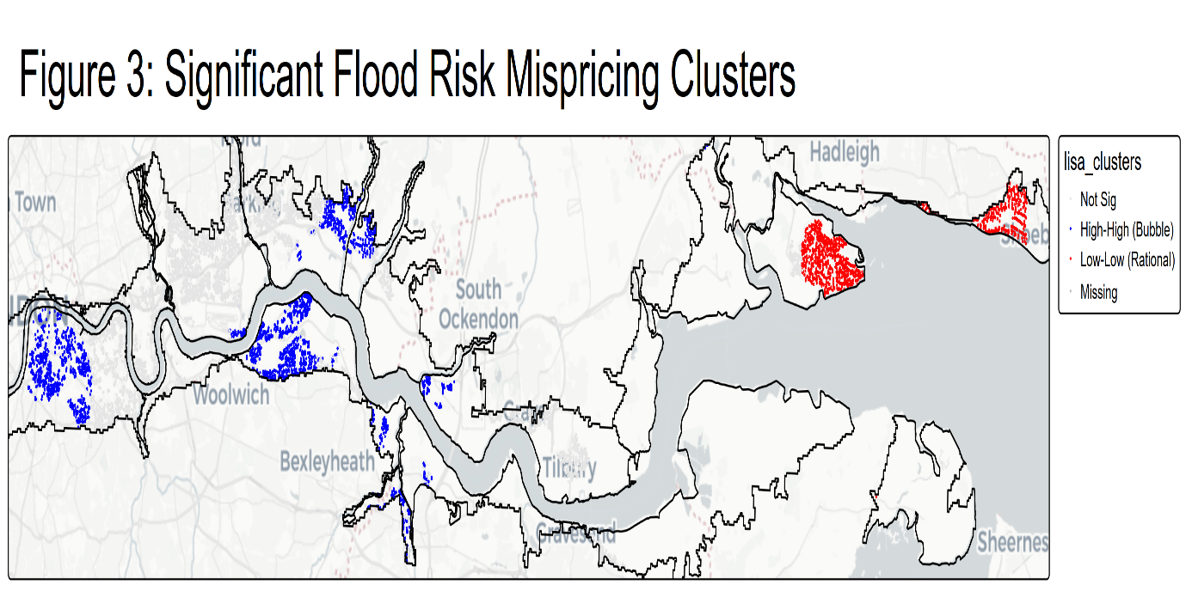
Figure 3: LISA Cluster Map Identifying Significant Flood Risk Valuation Bubbles

Table 5 presents the localized PMU summary provides the empirical evidence of spatial heterogeneity in flood risk pricing. In the eastern reaches, specifically Isle of Grain $\left(β= -0.298\right)$ and Leigh Old Town $\left(β= -0.292\right)$, the market demonstrates a strong rational response, where properties in flood zones are significantly discounted. Conversely, units like Dartford & Erith $\left(β= 0.156\right)$ and Thamesmead $\left(β= 0.109\right)$ exhibits high positive premiums despite flood exposure, suggesting that local amenities or market demand are masking environmental risks
The high significance rates in units like Greenwich (98.4%) and Canvey Island (94%) confirm that these local pricing patterns are consistent markets trends rather than localized outliers.

Table 5: Summary of GWR Local Flood Risk Impacts and Model Performance by Policy Management Unit (PMU)
Policy Units (pmus) | N_Properties |  | Median_FZ3_Beta |  | Median_Local_R2 | Significance Rate
Isle of Grain (P4) | 1 | -0.2982 |  | 0.446692 |  | 100
Leigh Old Town and Southend-on-Sea (P4) | 3086 | -0.29231 |  | 0.640405 |  | 100
Canvey Island (P4) | 7622 | -0.24814 |  | 0.434998 |  | 94.01732
Greenwich (P5) | 1441 | -0.05275 |  | 0.541409 |  | 98.47328
East Tilbury & Mucking Marshes (P3) | 393 | -0.04961 |  | 0.525775 |  | 93.89313
Shell Haven & Fobbing Marshes (P3) | 287 | -0.04933 |  | 0.500102 |  | 40.41812
London City (P5) | 634 | -0.04878 |  | 0.708452 |  | 72.87066
Isle of Dogs & Lea Valley (P5) | 2782 | -0.03542 |  | 0.532862 |  | 69.12293
Purfleet, Grays & Tilbury (P4) | 5780 | -0.01973 |  | 0.617526 |  | 36.6263
Royal Docks (P4) | 12362 | -0.00951 |  | 0.227243 |  | 8.574664
Swanscombe & Northfleet (P4) | 19 | -0.00448 |  | 0.586845 |  | 0
North Kent Marshes (P3) | 991 | -0.00329 |  | 0.57967 |  | 0
Wandsworth to Deptford (P5) | 9530 | 0.007242 |  | 0.637411 |  | 69.91605
Barking & Dagenham (P4) | 7757 | 0.034057 |  | 0.336622 |  | 47.325
Rainham Marshes (P4) | 2943 | 0.054027 |  | 0.412096 |  | 59.70099
Thamesmead (P4) | 6343 | 0.109222 |  | 0.370902 |  | 87.04083
Dartford & Erith (P4) | 2976 | 0.156295 |  | 0.542342 |  | 100
Note: Data represents median values for all properties within the specified Policy Management Unit. The "Significance Rate" indicates the percentage of properties within that unit where the local flood risk impact is statistically significant $\left|t\right|>1.96$

